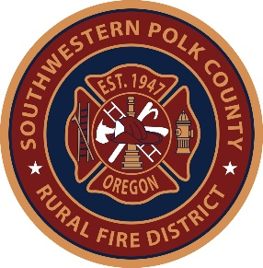
All community members are encouraged to attend.
Your voice matters. Be informed.

APRIL 8, 2026
Bridgeport Community Fire Station
6040 Kings Valley Hwy, Dallas
- 5:30 PM – Hot Dogs
- 6:00 PM – Live Fire Demonstration
- 6:20 PM – Speaker

APRIL 15, 2026
Salt Creek Community Fire Station
15455 Salt Creek Road, Dallas
- 5:30 PM – Hot Dogs
- 6:00 PM – Forcible Entry Demonstration
- 6:20 PM – Speaker

MAY 6, 2026
Rickreall Community Fire Station
9105 Rickreall Road, Rickreall
- 5:30 PM – Hot Dogs
- 6:00 PM – CPR Demonstration
- 6:20 PM – Speaker

Learn more about Measure 27-148
and how it impacts fire and emergency services in your community.

✔ Meet your local firefighters
✔See live demonstrations
✔ Get your questions answered
✔ Be informed before the vote

